MIS 328

APPLIED OPERATIONS RESEARCH

**GAS STATIONS QUEUE PROBLEM**

Prepared by

Zeynep YARAMAN (181005005)

Ayça AŞIK (181005013)

**OUR PROBLEM**

While deciding what we should choose as our problem, we defined two criteria: familiarity and nicheness. We wanted to be familiar with the problem’s solving process, and because of that, we wanted to solve a problem about queue systems. Apart from familiarity, we wanted to find a niche queue that many people would not care about unless they experience the said problem frequently. Due to that reason, we tried to find a niche queue problem that one-time experiencers would not care about, yet people who experience it frequently get frustrated. We talked about different queues that satisfy these two criteria, and we decided the best queue problem that satisfies our criteria is the gas station queue.

Not many people drive cars and even if they do, not many people experience this frequently. However, for those who live in crowded areas and especially for people who experience this during the late hours of the day, waiting in the long queues at the gas station can be a very frustrating and maddening problem. Long queues at gas stations can be caused by many things. For example, according to the news on the internet such as an article in Euronews, people in Kenya currently experience long queues at petrol stations problem due to fuel restrictions in their country. Even though the reason for the queue might change, the only thing that does not change is that people do not want to be in these queues.

To sum up, our problem is the long queues at the gas stations, and we want to find a solution as effectively as possible. According to the stories we saw on the internet, and the times we experienced this problem, the waiting time can go up to 45 minutes. On the grounds of our observations, people who experience this problem are mostly people who just left their work/school to go back to their homes. As a result of that, we can also say this problem mostly occurs during rush hour.

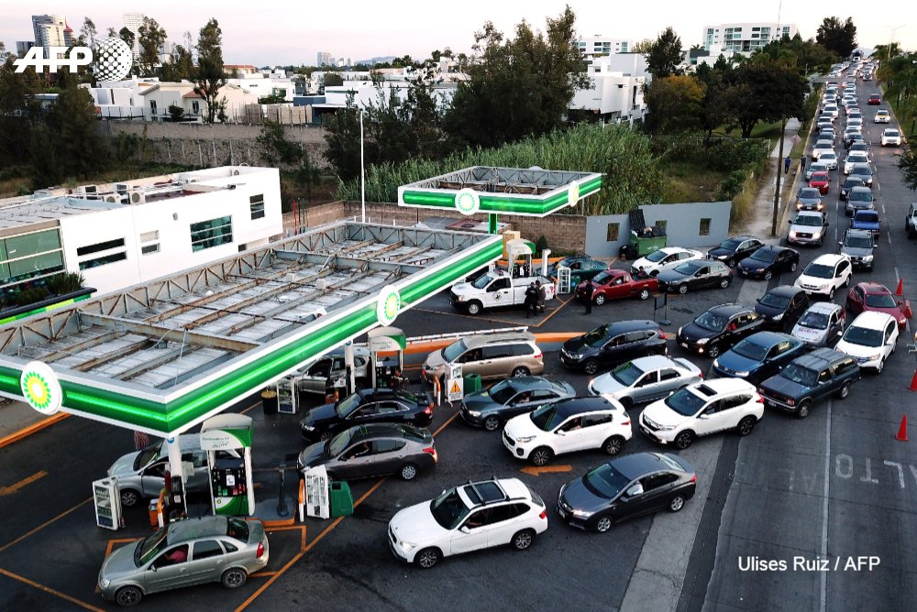

An example of long queues at gas stations. (Source: AFP News Agency)

**OUR PROPOSED MEASUREMENTS**

In order to solve this problem in gas stations and to get effective results, we will conduct measurements on both the drivers and the suppliers, and we will perform the measurements on two subjects: arrival and service process.

* For the arrival process of the drivers, we will observe a certain fuel station and take note of drivers’ arrival and exit times, particularly during hectic periods when there are busy waiting queues.
* For the service process, we will measure the time between when the vehicles begin to get gas and when they make the payment and end the service, and again we will consider the busiest period at a certain gas station.

We will also utilize statistical distribution tests to assemble and summarize the results we will acquire once both measures are completed.

We haven't started the observation week as a group yet, but based on prior research and experiences, we can say that the time a car spends in gas stations can range from 4 to 45 minutes and the average number of drivers waiting in line ranges from 3 to 15.

**OUR MODEL**

Since we are working with a gas station queue, we will employ the Multiserver Waiting Line Model (M/M/c), in which stations have two or more operators available to assist consumers. And our discipline to this issue will be First Come First Served (FCFS), where the first driver comes will be the first to be served.

Another example of long queues at gas stations / London. (Source: Reuters / Peter Nicholls)